iThenticate Guide for Supervisors
iThenticate is a similarity detection tool meant to be used by researchers to check any original works that will be publicly released and who are concerned about potential plagiarism. The software allows the user to delete the scanned work from their servers after a report has been generated.
According to McMaster's Research Plagiarism Checking Policy, it is expected that all graduate theses, whether Masters or Doctoral, shall be checked for plagiarism in compliance with this Policy. Plagiarism checking is expected to occur prior to the coordination of the defence and Supervisors of Masters students will need to sign a separate attestation sheet indicating that this has occurred and the document is satisfactory for public disclosure. PhD Supervisors will be prompted to confirm this in the Admin Tools system once their students initiate their defence.
To protect graduate students’ privacy, only Academic Supervisors will have access to this software and will be responsible for uploading their students’ theses. It should not be used to check documents submitted to instructors as course assignments. Turnitin is intended for scanning course work.
Theses shall be checked before being sent to an External Examiner for PhD defences and before it’s submitted to MacSphere; in both cases, the scan occurs before public disclosure.
Please note: The School of Graduate Studies is unable to delete submissions to iThenticate and it will be the responsibility of the Supervisor to remove any uploaded file.
- Getting Started
- Folders
- Documents
- The Similarity Report

Getting Started
iThenticate Quick Start Guide
This Quick Start guide will help you get started using iThenticate. First-time users will receive an email with a username and a one-time password. You may only log in once with the one-time password and you will need to change it the first time you log in.
To log in to iThenticate, select the Login button at www.ithenticate.com.
Enter your email and the password into the appropriate fields and select Login.
iThenticate will provide you with a folder group My Folders and a folder within that group titled My Documents.
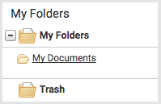
From the My Documents folder, you will be able to submit a document by selecting the Submit a document link.
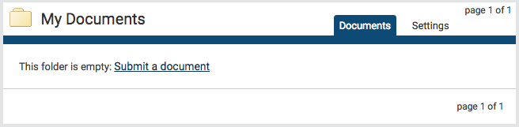
On the Upload a file page, enter the authorship details and the document title. Select Choose File and locate the file on your device.
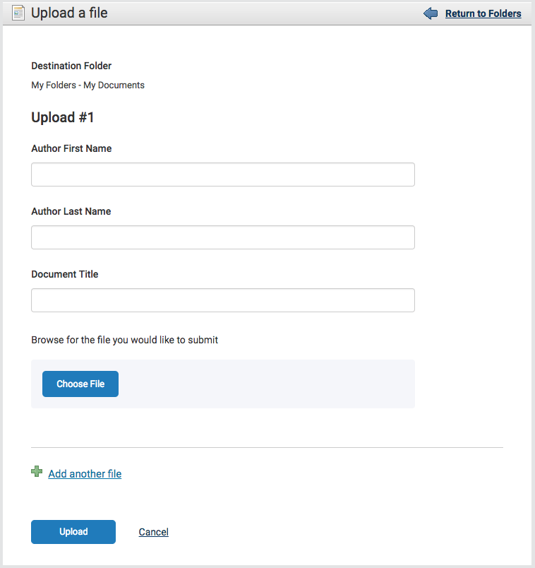
After choosing the file, click on the Upload button. The system will automatically take you back to the My Documents folder.
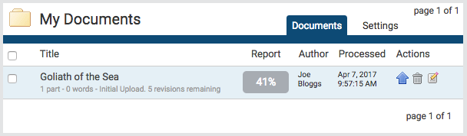
To view the Similarity Report for the paper, click on the similarity score in the Report column. It usually takes a couple of minutes for a report to generate.
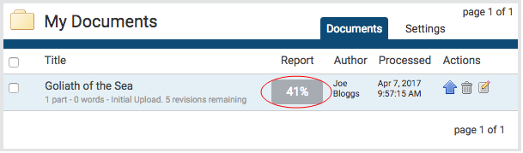

Folders
This is the main area of iThenticate. From the folders page, you will be able to upload, manage and view documents.

Create a new folder
To create a new folder, select the New Folder link from the New folder section on the right of the screen.
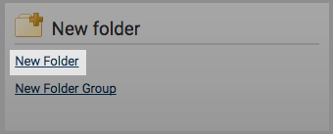
In the Create A New Folder page, you’ll have to specify which folder group you would like to save this new folder to by using the Folder Group drop-down menu. After that, enter the folder name into the Folder Name field.
The next section of the form will allow you to exclude certain text from the Similarity Check for all documents uploaded into this folder. By invoking the relevant tick boxes, you will be able to exclude quotes, bibliography, certain phrases you can set in the account information area, small matches and small sources.
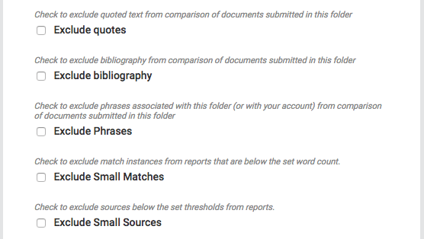

Documents
Managing your documents
The documents tab within a folder displays all the submitted documents for that folder. Each submitted document generates a Similarity Report after the document has been through the Similarity Check.
Only a specified amount of documents are displayed on the screen at once, if more documents are in the folder but not displayed, the pages feature will appear beneath the documents. Either select the number of the page you would like to be displayed or select Next to scroll to the next page of documents.
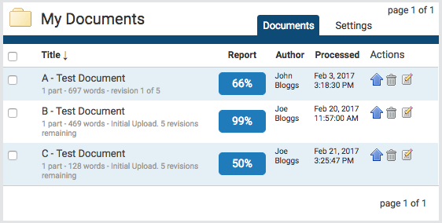

Submitting a Document
iThenticate users can submit documents in three ways.
- Upload a File - a single file submission, or
- Zip File Upload - submit a standard zip file containing multiple documents. May contain up to 100MB or 1,000 files. Zip file uploads of significant size may require additional time to complete, or
- Cut & Paste - submission of text copied and pasted into the submission box. May be used to submit from a file format that is not accepted. No images or non-text information can be copied and pasted - only plain text can be accepted.
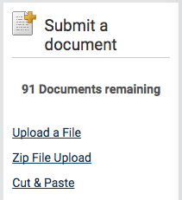
File Types and Size
The file may not exceed 800 pages. The file size may not exceed 100 MB. Files of larger size may be reduced in size by removal of non-text content. Files that are password protected, encrypted, hidden, system files, or read only files cannot be uploaded or submitted to iThenticate.
The zip file upload accepts up to 1000 files or 100MB of zipped information. A zip file to be uploaded may not exceed either limit. Zip files should be checked to ensure only usable file formats are included in the upload.
PDF documents must contain text to be submitted. PDF files containing only images of text will be rejected during the upload attempt. To determine if a document contains actual text, copy and paste a section or all of the text into a plain-text editor such as Microsoft Notepad or Apple TextEdit. If no text is copied over, the selection is not actual text.
Users submitting scanned images of a document, or an image saved as a PDF will need to use Optical Character Recognition (OCR) software to convert the image to a text document. Manual correction of the resulting document is highly recommended to fix any errors caused by the conversion software.
Some document formats can contain multiple data types. This includes text, images, embedded information from another file, and formatting. Non-text information that is not saved directly within the document will not be included in a file upload. This includes references to a Microsoft Excel® spreadsheet included within a Microsoft Office Word document.
Users whose files are saved in a file type that is not accepted by iThenticate will need to use a word processing program to save the file as one of the accepted types. Rich Text Format and Plain Text file types are nearly universally available in word processing software. Neither file type will support images or non-text data within the file. Plain text format does not support any formatting, and rich text format supports only limited formatting options.
Users who are converting to a new file format will need to save their file with a name different than the original. Any file should be saved with a new file name when converting to plain text or rich text formats to prevent permanent loss of the original formatting or image content of a file.

File Upload
The Upload a File option allows the user to submit a single document from a variety of document types. Select the Upload a File option from the Submit a document menu. This will open the Upload a file form.
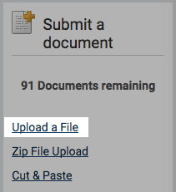
Use the Destination Folder drop-down to choose the folder you would like to upload this file to. This is where the similarity report for the file will be found.
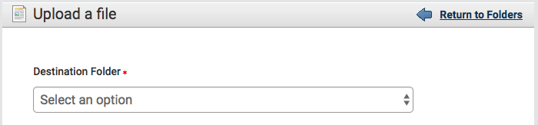
Enter the author’s first and last name in the Author First Name and Author Last Name fields. Enter the document title in the Document Title field. If no title is entered, the document’s filename will be used.
Select Choose File to open a file browser and locate the file on your device.
The user can upload up to ten documents at once using the Upload a File submission option. To add another file to upload, select the Add another file link.
Select Upload to upload the selected document or documents. Select Cancel to cancel the upload.

The Trash folder
Once deleted from a folder, a file will remain available to restore from the Trash folder.
Access the Trash folder from the bottom of the My Folders section.

Permanently deleting a document
To permanently delete a document, select the checkbox to the right of the document title in the Trash folder. You can select multiple documents to delete. Once you have selected the documents you would like to delete, select Delete from the top menu.
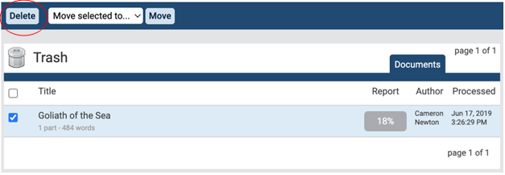
This action cannot be undone. There is no option to confirm your action or undo it directly after. Selecting Delete will immediately and permanently delete the file.
Documents that have been added to a private repository but have then been deleted will remain searchable and continue to compare against future submissions until they have been deleted from the Trash folder. Only when a document has been permanently deleted from the Trash folder, will it no longer compare against future submissions. Please allow a processing time of a few minutes after the deletion before considering the document unindexed. After 90 days, the file will be completely erased from our system.

The Similarity Report
iThenticate compares files against an ever-expanding database of Internet pages, archived pages that might not be available anymore, a subscription repository of periodicals, journals, and publications.
Interpreting the Similarity Report
iThenticate makes no determination of plagiarism in a submission. It merely checks a submission against the content database, and if there are instances where the submission's content is similar to, or matches against, one or more sources, it will be flagged for review. The database includes billions of web pages (both current and archived content), a collection of documents, which comprises of thousands of periodicals, journals, publications, and CrossRef member content.
It is perfectly natural for a submission to match against sources in the database, especially the reference section of a document, or in the case of a sandwich thesis, match with one’s own published papers. If the submission has used quotes and has referenced correctly, there will be instances where there will be a match. The similarity score simply makes the user aware of any potentially problematic areas in the submission; iThenticate should be used as part of a larger process, to determine if the match is or is not acceptable.

Accessing the Similarity Report
To view a submitted document’s Similarity Report, navigate to the folder that contains the submission.
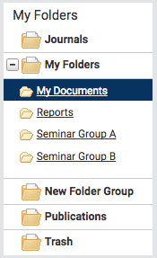
The submitted document will be shown in the Documents tab of the folder. To view the Similarity Report, select the similarity index icon for that document. This is the percentage that is shown in the Report column.
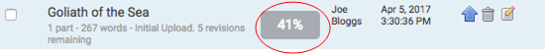
This percentage is the Similarity Score. It is an accurate representation of the document, offering an immediate indication of the document’s performance but it always warrants further exploration. Once selected, the report will open in the document viewer.

Report FAQs
How is the similarity Index calculated for each of the reports?
The similarity index does not change when viewing different report modes. To calculate the Similarity Index, our system first makes a digital fingerprint of the submitted document’s text and searches it against each of the repositories selected to be searched against within the system. Then once the document is scanned against the selected content repositories our system takes the # of matching words our system found within the document and divides it by the document's total word count to produce the Similarity Index percentage for the report.
If exclusion options are applied to the document our system would recalculate the similarity index percentage and remove all matches that the exclusion option logic excluded from the report.
How is the Similarity Report constructed? What matches get hidden by other matches?
As much of the information surrounding the Similarity Report is proprietary, the following is a brief description of how the report is constructed. A document submission is converted into what we refer to as a digital fingerprint that our system then uses to search against our content databases using our proprietary algorithm. Our system then paints the document with highlights for each section of text that matches a source within our repositories. What our system deems to be the best matches to the sections of text are listed in the report sidebar. Although the best matches are listed there may be hundreds to thousands of other sources that match the document’s text. These underlying sources are listed in the Content Tracking mode.
What if two sources have the exact same amount of matching text; which source would be displayed in the Similarity Report as a best match?
This entirely depends on which repository the document matched to. For example, if two internet sources were found to match the identical section of text, the most recently crawled internet source would be displayed as the best match. If an internet source and a publication source were found to match an identical section of text, the publication source would be displayed as the top match.
Are my submissions to iThenticate kept private?
Yes. Submissions are added to a private, secure database that is only accessible by your own account. Unlike many free plagiarism checker services, iThenticate does not share or resell uploaded files. Your submissions are not searchable by any other account, nor used by any other Turnitin service.
Can I delete my submissions from iThenticate?
Yes. You may delete your submissions from your account at any time. Deleted submissions will be moved to your Trash folder and permanently removed from the iThenticate database once you click “Delete” in your Trash folder.
Is there a way to download the similarity/summary report before deleting the document off of iThenticate?
Yes. Click on the percentage button as you normally would to look at the similarity report. On the bottom left of the report, click on the printer icon. This will download a PDF version of the similarity report which shows the same information that is on the screen when you first go into the similarity report.
Another option is to click the “Text-Only Report button on the bottom right of the Similarity Report. From this page, you can select from 1-3 different modes (Similarity Report, Content Tracking and Summary Report). When you have selected the mode you want, you can either print the document or download it as an html file.

